Friendship News, March 2025

0

First Congregational United Church of Christ, Brainerd

An Open and Affirming Congregation

The Church Office Hours: Wednesdays – Fridays from 10:00am – 2:00pm

Office phone 218-829-2528 Office E-mail [*uccbrainerd@gmail.com*](mailto:uccbrainerd@gmail.com)

Pastor Leslie’s E-mail: [*pastorleslieucc@gmail.com*](mailto:pastorleslieucc@gmail.com)Website: [*www.uccbrainerdmn.org*](http://www.uccbrainerdmn.org)

*No matter who you are, or where you are on life’s journey, you are welcome here.*

0

**Pastor’s Pen**

0

***Becoming Purveyors of Awe***

In times of anxiety, fear, and frustration, or when I have felt a lack of direction - aimlessness, it has often been experiences of awe and wonder that have called me back to a sense of well-being and wholeness. These experiences of awe do not replace other components of wholeness and wellness like therapy, medication or community. But they add a sense of spiritual depth to my life that is uniquely healing.

During this season of Lent, we will be exploring how we might become “Purveyors of Awe.” The idea is that we can make the world a better place, not only by inviting people into the church community, not only by programs that alleviate suffering (and all that is right and good), but also by inviting people to be simply and deeply well. But in order to become Purveyors of Awe, we need to discover it for ourselves.

What is “awe?” Dacher Keltner writes “Awe is the emotion we experience when we encounter vast mysteries that we don’t understand.”[1] The beauty of awe is that we can find it anywhere. Finding awe doesn’t require a plane ticket or a large bank account. It is possible to experience awe right where you are, just as you are. Whether through nature, art, ritual, or human interaction, embracing awe can enrich our journey, deepen our spiritual life, and make us better human beings.

I hope you will join me over the next six weeks as we seek curate lives of spiritual depth, cultivating an attunement to experiences of awe.

With Peace,

Mission Statement of First Congregational UCC

0

***“To know and share God’s love within us.”***

Purpose Statement of First Congregational United Church of Christ

***“First Congregational UCC is a welcoming, inclusive, and progressive community committed to promoting social justice, spiritual growth, and love for all people. We reject discrimination and advocate for equality and dignity for marginalized communities. Through worship, education, and service, we work to make a positive impact on the world and invite all individuals to join us in this journey of faith and service.”***

0

**Church Office Hours**

**Wednesday, Thursday, Friday 10:00 am - 2:00 pm**

Please call Admin. Asst. Terri at the office 218-829-2528

**Pastor Leslie’s Workday Schedule**

**Sunday through Thursday (Days off are Friday and Saturday)**

**Drop-in Hours: Wednesdays 11:00 am – 1:00 pm Thursdays 2:00 – 4:00 pm**

*\*Drop-in hours are times set aside for “drop-in” conversations, much like a professor’s office hours.*

Everyone is encouraged to make an appointment, especially if the above times are not convenient.

You can go to [*www.calendly.com/pastorleslieucc*](http://www.calendly.com/pastorleslieucc/) and select a day and time that works for you, or you can email Pastor Leslie at [*pastorleslieucc@gmail.com*](mailto:pastorleslieucc@gmail.com) or call/text at 218-656-0096.

**First Congregational UCC News & Updates**

0

**Our website has a new look – Check it out!**

***www.uccbrainerdmn.org***

0

**Stay Connected**

**How to watch Sunday worship:** The worship service is **broadcasted on the church Facebook page and the church's YouTube channel every Sunday at 10:00 am.**  
To watch worship on Facebook, go to [*https://www.facebook.com/uccbrainerd/live*](https://www.facebook.com/uccbrainerd/live)  
***\*\*Live stream videos are saved and can be viewed at any time. All memorials, weddings and 12th Night Concert are on our church Facebook page.***

**How to stay connected with First Congregational friends and members:** Join the private group for our Facebook Connections Page at [*https://www.facebook.com/groups/uccbrainerd*](https://www.facebook.com/groups/uccbrainerd)*.*

**Financial Help Available** The Pastor's Discretionary Fund is available to assist church members and others in the Brainerd area who are experiencing financial distress with modest financial help. If you need assistance, please email, call, or text Pastor Leslie. Let her know what your situation is and how the church might be of help.

**Donate to the church online!**We are now accepting your offerings and donations using **PayPal.** You do not need to have a PayPal account to make an online donation with a credit card. To use PayPal, go to: [*https://www.paypal.me/uccbrainerd*](https://www.paypal.me/uccbrainerd)

0

**Ash Wednesday Worship Service**

**March 5th @ 5:30 pm**

The season of Lent begins on Ash Wednesday. Lent is a time to pay attention. It is historically a time of heightened spiritual practices in the lives of Christians.

We make more room for contemplation, more room for prayer, more room for study. This year, we will make more room for awe. We will become “purveyors of awe”–those who promote and dispense a precious good.

Join us as we open ourselves to the awe that is the beauty of life in between the first and last breath and pause in awe of the story of being alive.

0

In addition to Sunday worship, join us **Wednesdays at 5:00 pm for "Soup and Awe."**  
**Beginning March 12th**, we will gather for a soup supper and engage in a combination of study, reflection and a practice of Awe. We will be utilizing a study guide and journal to deepen our understanding of awe. Join us for one week or for all five!  
  
The series will also be informed by the book, "Awe: The New Science of of Everyday Wonder and How It Can Transform Your Life" by Dacher Keltner. While there will not be a formal book study, reading this book will be a great way to enrich your experience.  
Copies can be purchased online at many outlets including [Thirftbooks.com](https://www.thriftbooks.com/w/awe-the-new-science-of-everyday-wonder-and-how-it-can-transform-your-life/36836378/?utm_source=google&utm_medium=cpc&utm_campaign=us_dsa_general_232080312&utm_adgroup=&utm_term=&utm_content=474966288148&gad_source=1&gclid=Cj0KCQiAwtu9BhC8ARIsAI9JHal_EeKV94dUm17euF89AoQepHlIhkTOm2jEp3k7XWx78vGGmQ2lDw8aAuBsEALw_wcB#edition=69926627&idiq=64056907)  
  
**Let us approach this season of Lent with Awe**

**Elizabeth "Itty" Newgord**

0

November 21, 1951 - February 25, 2025

Itty Newgord, passed away the morning of Tuesday, February 25th surrounded by loved ones.   
  
**Visitation will be Friday, March 7 from 4:00pm - 7:00 pm in Fellowship Hall, and 11:00 am on Saturday, March 8.**

**A memorial service will take place on** **Saturday, March 8 at 12:00 pm** at First Congregational with a luncheon to follow.  
Please hold Itty's family and friends in your prayers.

*https://www.halvorsonjohnson.com/obituaries/obituary-listings?obId=37909585*



0

0

0

**Movie Night**

**Rescheduled to Friday, March 14**

“Driving Miss Daisy”

Starring Jessica Tandy and Morgan Freeman.

*"Over 25 years, as the American South changes profoundly, the friendship between a highly independent, eccentric Jewish matron and the stalwart and very patient black widower her son hires as a chauffeur endures and deepens, testing the limits of their differences and similarities."*

0

0

**March Adult Forums - 11:30 after Worship Service**

**March 9th - “What’s in a Name” Dan Hegstad & Marcia Ferris:** This adult forum will take a dive into our church's identity in the community and explore the option of intentionally changing our church name. "Congregational" has not been a denomination since the merger in 1957. **We became UCC after the merger and that will not change.**

(That is the big concern we have heard voiced, we will not be changing being UCC!)

We will explore 'why would we change our name?' and what other churches have done (our research started January 2024 with Council authorization.)  We will have handouts on the research. There was information and a report in the August & September 2024 monthly newsletter. Come for the discussion. There will be more forums. We want everyone's voice heard!

**March 23rd - Justice Sunday - Justice Action Teams:** We will meet again during Adult Forum time. Each team will provide an update on their work with time for Q&A and a discussion time. This is your opportunity to hear what the teams are planning and add your perspective.

0

**Annual Connection Letter & Church Directory**

Our church is sending out the letter soon and we kindly request you to fill out and return. ***This information will help us update our membership list, the Church Directory and make informed decisions about programs, and much more***. Your response is important to help us better connect with one another and better serve our members and visitors. **So,** keep your eyes on your mailbox and send back the completed form asap!

If you do not receive a letter and would like one, please contact Terri in the church office.

Has your contact information changed? Do you want to be removed from or added to the directory? **The Annual Connection Letter provides the needed information in updating the church directory**. **Please Help us stay connected and return it completed by April 1st! Thank you!**

0

**Choir is Back!**

0

**If you are interested in singing with the choir,  
please arrive to rehearsals at 8:30 am in the Sanctuary**

**Rehearsal Dates 2025: March 16th, April 13th, April 20th**

0

Easter Flowers 2025

**You have the opportunity to give a gift in the name of your loved one(s).**

**We will use the money to purchase flower arrangements for the altar.**

**All memorials will be listed in the Easter bulletin.**

**\* * * * * * * * * * * * * * * * * * * * * * * * * * * * * * * \***

**Please fill out the following completely.**

# **Amount of Memorial Gift: $___________________________________**

**In Memory Of: ________________________________________________**

**________________________________________________**

**________________________________________________**

**Your Name(s): ________________________________________________**

## Write your check to: “First Congregational Church”

**Memo: “Easter Flowers”**

**Leave this form with your check in the offering plate,**

**the church office, or mail it to:**

**First Congregational Church**

**415 Juniper Street Brainerd, MN 56401**

**March Birthdays**

0

Sharon Carlson March 4 Deb Griffith March 21

Mary Johnson March 4 Jonathan Howard March 23

Michael Imsdahl March 6 Brian Gustafson March 24

Marina Grabowski March 16 Melinda Ellis March 27

Tim Anderson March 21 Patricia Scott March 29

0

**Church Leadership**

**Get Involved, Give Back, Grow Connections – Volunteer at Church!**

***There are many other opportunities for you to share your talents!***

**Council & Committees needing fresh faces and leadership:**

\***Council Member-At-Large:** Attend council meetings, act as a liaison for church members and council, help with nominations, spokesperson for historically underrepresented groups (HUGS).

**\*Christian Education *Music *Arts *Trustees**

*Contact Mary Reardon - Moderator with your nominations*

0

**Next Council Meeting: *Thursday, March 20th 2025, 4:30 pm***

**in-person and via Zoom** [*tinyurl.com/uccbrainerdzoom*](http://tinyurl.com/uccbrainerdzoom)

**Reports are due Monday, March 17th.**

0

**First Congregational Council Meeting, February 20, 2025**

**Thank you to Georgia Harris for your service as our Council Clerk!**

Georgia has stepped down from the position of clerk. Minutes from the February meeting of the church council will be shared in next month’s newsletter.

0

**Sunday, March 23rd**

**One Great Hour of Sharing (OGHS)**

**UCC Missions**

The theme for the 2025 One Great Hour of Sharing® is **Be the Light.** The United Church of Christ invites you to join this meaningful Lenten offering, which supports disaster relief, refugee assistance, and development ministries through Love of Neighbor.

Please send your donation to First Congregational UCC, 415 Juniper St. Brainerd, MN 56401. Make sure to note on your offering: “Special Offering One Great Hour of Sharing (OGHS)”.

Or for your convenience use our Paypal account at:[*paypal.me/uccbrainerd*](https://www.paypal.com/paypalme/uccbrainerd)

Be sure to note on your offering “Special Offering One Great Hour of Sharing (OGHS)” in the notes. Thank you!

0

**UCC & TheShop Meal!**

Meal cooking is **Wednesday, March 26th at 3:30 – 5:30 pm.** First Congregational has provided a space in the Fellowship Hall and kitchen where youths prepare a meal for the youth at TheShop - Brainerd Baxter Youth Drop-in Center.

A number of youth and staff from TheShop come over to our kitchen and help prepare a delicious meal that is then brought back to TheShop for the hungry and appreciative teens there.

If you are interested in joining and enjoy cooking with youth, please contact Breton Monroe

Executive Director, #218.316.2070 or TheShop #218.454.0009. [*https://theshopbrainerd.org/*](https://theshopbrainerd.org/)

0

**UCC Care Team**

For anyone who wishes to join in making calls or visits, **the Care Team meets every month on the first Thursday @ 10:00 am**.

If you know of anyone who would enjoy a call from the care team, please contact one of our Care Team; *Barb Hoeft, Jack and Kay Kraywinkle, Pat Scott, Chris Yager, Deb Griffith, Joey Halvorson (text or email) and Pastor Leslie.*

0

0

**H.U.G.S.**

**Hosts, Ushers, Greeters, Scripture-readers**

Sunday morning greeters/ushers and coffee hosts play an important part in making our church a warm and welcoming place for all. Signup below for your first Sunday as the face of the church! [*https://www.signupgenius.com/go/10C0E48A9A823A5FFC07-hugs/16034811*](https://www.signupgenius.com/go/10C0E48A9A823A5FFC07-hugs/16034811)



**Friday Book Group**

0

**We meet each Friday morning at 10:30 am via zoom**.

Church Zoom link: [*https://tinyurl.com/uccbrainerdzoom*](https://tinyurl.com/uccbrainerdzoom)

We are now reading **“James” by Percival Everett.** A brilliant, action-packed reimagining of *The Adventures of Huckleberry Finn*, both harrowing and ferociously funny, told from the enslaved Jim's point of view.

Contact Pat Scott for more information.

0

**First Congregational Food Shelf Collection**

**Our church continues to collect non-perishable food items for the Salvation Army Food Shelf. Please consider donating.**

**There are two collection boxes: one in the parking lot entry hallway, the other in the Narthex. Thank you, Brian Twamley and Stephanie Lee, for picking up and delivering the food to the Salvation Army.**

**You may also send a financial donation to the church;** First Congregational UCC

415 Juniper St. Brainerd, MN 56401. Or for your convenience use our PayPal account at: [*paypal.me/uccbrainerd*](https://www.paypal.com/paypalme/uccbrainerd) **Make sure to write in memo “Food Shelf”.**

0

**The Columbarium & Memorial Garden**

**First Congregational UCC, Brainerd**

The Columbarium is in the historic space that once was our church’s front entry way.

How appropriate it is that our Columbarium now marks another entry way into a new life — where the Spirits of Love and Truth are always present!

The Memorial Garden is located on the south lawn of the church. The Garden provides a place for cremains of your loved one to be buried in the ground among natural plantings. The Garden fee includes the inscription of your loved one’s name on a granite plaque that is mounted on the outside wall of the church.

Should you wish to learn more about the purchase of a niche for your own cremains or for the ashes of a loved one, please call the church office at (218) 829-2528 and a packet of materials will be sent you via email or regular mail. The Memorial Committee has prepared the information packet, and it contains all the details you will need as you consider inurnment here at First Congregational UCC.

0

|  |
| --- |
|  |

**Welcome to our Facility**

0

It is the policy and privilege of the First Congregational United Church of Christ (UCC) Brainerd, to share its beautiful church facilities for purposes that match the values of the church and its mission which is “to know and share God’s love within us.” We are an open church valuing the diversity of age, culture, gender identity, opinions, physical and mental abilities, and sexual orientation.

To request a space for general use, ask for a “Request for Church Building Use” form and policy packet from the church office, administrative assistant Terri at 218-829-2528 or email *uccbrainerd@gmail.com.* Submit the request form to the administrative assistant. For wedding or funeral use, contact the Pastor Leslie: [*pastorleslieucc@gmail.com*](mailto:pastorleslieucc@gmail.com)

0

**Answer this Bible Trivia Question and Win a Prize**

Be the first person to call or email the office with the correct answer to this trivia question and win some UCC Swag:

***What instruction does God give Moses when he approached the burning bush?***

Congratulations to last month’s winner: Kay Cox!

**Brainerd Lakes & Surrounding Area Information**

0

**~ Opportunities to Know and Share God’s Love ~**

0

**Doctrine of Discovery**

**On April 2, 2025, from 2:00 to 3:30 pm,** Sarah Augustine will give a presentation on the Doctrine of Discovery at the St. Francis Convent in Little Falls.

Sarah is a Pueblo (Tewa) descendant and the founder and co-chair of the Coalition to Dismantle the Doctrine of Discovery.

She is also the author of The Land is Not Empty (2021). Join us for stimulating information and discussion.

0

0

Carla Anderson Benjamin (BHS 1973), Deborah Goble Erickson (BHS 1991),Lee Gunsbury Seipp (BHS 1978), Dr. Meghan Thurlow (BHS 2001), and Laurie Potvin Wig (BHS 1983), will be inducted into the Legendary Women of Brainerd Public Schools Hall of Fame on Brainerd Public School's Legendary Women Hall of Fame is now in its 7th year of celebrating the remarkable achievements of its women graduates over the past 150 years of public education.

Find out more about each inductee here: [*https://www.isd181.org/.../lege.../legendary_women_inductees*](https://www.isd181.org/district/bpsa/the_collections/index_of_representative_holdings/special_collections/legendary_women/legendary_women_inductees?fbclid=IwZXh0bgNhZW0CMTAAAR0x8g4d2IiNNTy5BDRak-JmZK6_YH1J2RTqFhDEOrtFTjJ6t-ToZSjhawQ_aem_hB0jh5Y4V4KlCwsTVAB9yQ)

**This event is FREE and open to the public.**

**Thursday, March 27, 2025!**

**Pre-Program Celebration: 4:30 p.m.**

**Program: 5:00 pm**

0

0

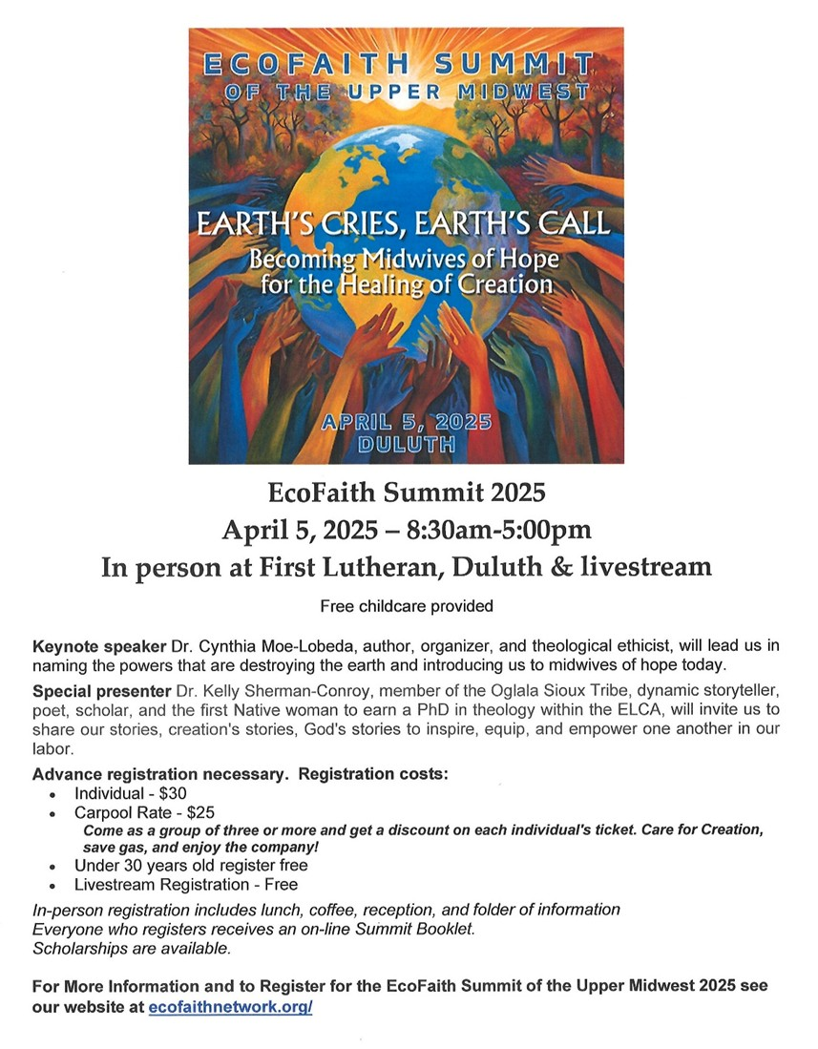

|  |
| --- |
| March 2025 Calendar |

|  |  |  |  |  |  |  |
| --- | --- | --- | --- | --- | --- | --- |
| Sunday | Monday | Tuesday | Wednesday | Thursday | Friday | Saturday |
| **Y- Yes Meeting in person**  **FB -Facebook Stream Online**  **Z-our church Zoom** | **C- Cancelled**  **N - No Meeting** | **? - No update**  **TBD - To be determined** | Office Hours  10am – 2pm  Pastor Drop-in Hours  11:00 am – 1:00 pm | Office Hour  10am – 2pm  Pastor Drop-in Hours  2:00 – 4:00 pm  **w/Daisy** | Office Hours  10am – 2pm | **1** |
|  |  |  |  |  |  |  |
| **2**  8:30am Bnrd Frnds-**Y**  10am Wrship & Communion-**Y**&**FB**  11am Fellowship-**Y** | **3**  7pm BACP/ BLUE-Z | **4**  2pm EA-**Y**  5:30pm OA -**Y** | 11:45pm - Men’s **5**  Grp-**Y**  1:30pm – Pastor Relations Meeting-**Y**  **5:30pm - Ash Wed. Worship Service-Y&FB**  7pm - AA Common-**Y** | **6**  10am - Care Team-**Y**  4pm - Chrstian Ministry-Y | **7**  10:30am Bk Grp-**Z**  **4pm to 7pm Itty Newgord Visitation in Fellowship Hall**  Movie Night rescheduled to next Friday | 9:30 am - Women’s **8**  Fellowship-**C**  **11am Itty Newgord Visitation in Fellowship Hall & 12pm Itty Newgord Memorial Service**  **Lunch follows service**  2:30-4pm BACP/BLUE Mtg. in upstairs room |
| 8:30am Bnrd Frnds-**Y**   **9**  10am Wrship-**Y**&**FB**  11am Fellowship-**Y**  11:15am Adult Forum “What’s in A Name”-**Y** | **10** | **11**  2pm EA-**Y**  5:30pm OA -**Y** | 10am Trustees-**Y 12**  11:45pm Men’s-**Y**  12pm – Memorial Mtg.-**Y**  **5pm Soup & Awe-Y**  7pm AA Common-**Y** | **13**  4:30pm Exec. Team Mtg**.-Y**&**Z**  6:30pm NAMI Mtg.-**Y** | **14**  10:30am Bk Grp- **Z**  6:30pm - Movie Night-**Y** | **15**  9:30am to1pm - AAUW Meeting-**Y** in Fellowship Hall |
| 8:30am Bnrd Frnds-**Y 16**  8:30am - Choir Practice  10am Wrship & Choir -**Y**&**FB**  11:45am Fellowship-**Y**  1:30pm Girl Scouts-**Y** | **17** | **18**  2pm EA-**Y**  5:30pm OA -**Y** | 11:45pm Men’s **19**  Grp@Wings Café-**Y**  **5pm Soup & Awe-Y**  7pm AA Common-**Y** | **20**  4:30pm Council Mtg-**Y**&**Z**  6:30pm Dist.7AA-**Y** | **21**  10:30am Bk Grp- **Z** | **22** |
| 8:30am Bnrd Frnds-**Y 23**  10am Justice Sunday  Wrship **-Y**&**FB**  11am Fellowship-**Y**  11:30am- Adult Forum “Justice Tables”-**Y**  ** Newsletter Deadline  **Special Offering: OGHS | **24** | **25**  2pm EA-**Y**  5:30pm OA -**Y** | **26**  11:45pm Men’s Grp-**Y**  1:30 PRC Mtg. -**Y**  3:45pm TheShop cooking-**Y**  **5pm Soup & Awe-Y**  7pm AA Common-**Y** | **27**  11:30 am Women’s Luncheon @ Baia Della in Baxter  6:30pm NAMI Mtg.-**Y** | **28**  10:30am Bk Grp- **Z** | **29** |
| 8:30am Bnrd Frnds-**Y**  **30**  10am Wrship-**Y**&**FB**  11am Fellowship-**Y** | **31** |  |  |  |  |  |

1. Keltner, Dacher. Awe: The New Science of Everyday Wonder and How It Can Transform Your Life (p. xvi). Penguin Publishing Group. Kindle Edition.